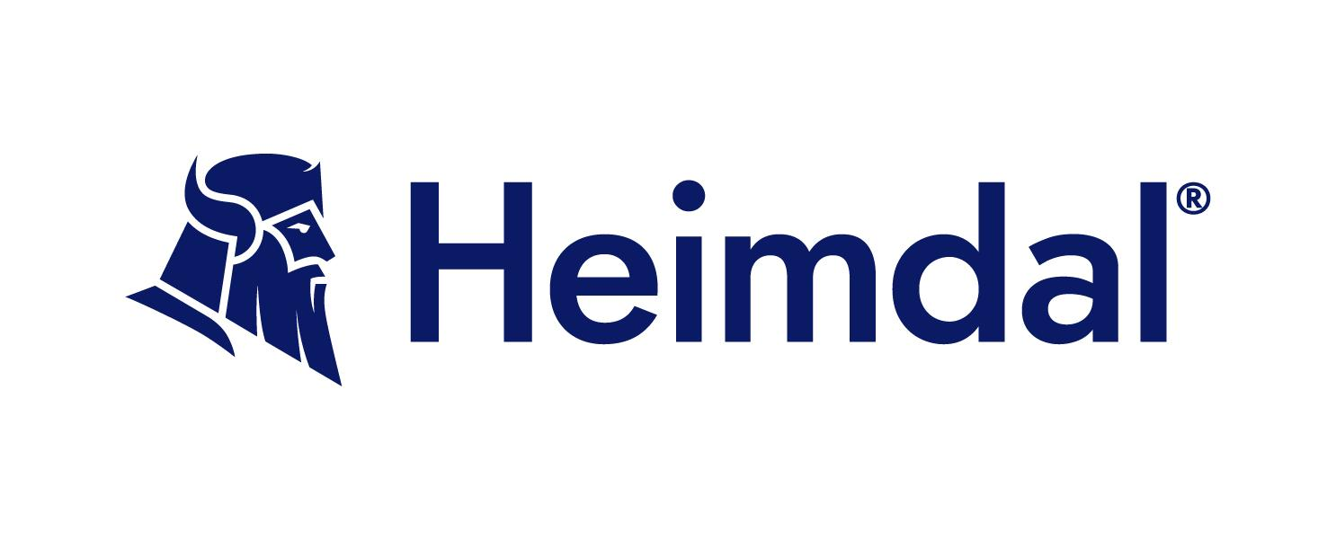

# Access Control Policy Template

## Document Control

**Organization Name:** [Name]

**Version:** 1.0

**Effective Date:** [Date]

**Review Date:** [Date]

**Approved by:** [Name]

**Policy Owner:** [Name]

**Policy Contact:** [Email/Phone]

---

## Purpose

The purpose of this Access Control Policy is to establish the principles and standards by which [Organization Name] will provide access to information systems, ensure security, protect sensitive data, and comply with relevant regulations.

## Scope

This policy applies to all employees, contractors, vendors, and other personnel with access to [Organization Name]'s information systems and data.

## Policy Statement

[Organization Name] will implement and maintain an effective access control system that ensures that access to information is restricted to authorized individuals, prevents unauthorized access, and protects the integrity and confidentiality of data.

## Roles and Responsibilities

* **Policy Owner:** Oversees the implementation and enforcement of this policy.
* **System Administrators:** Implement and manage access controls on information systems.
* **Managers/Supervisors:** Authorize access for their team members based on job requirements.
* **Employees/Users:** Adhere to the access control policies and procedures.

## Access Control Principles

| **Least Privilege** | **Need-to-Know** | **Role-Based Access Control (RBAC)** |
| --- | --- | --- |
| * Users should have the minimum level of access necessary to perform their job functions. | * Access to information should be granted only if it is necessary for the user to know to perform their job. | * Access permissions should be assigned based on the user’s role within the organization. |

## Access Control Measures

### User Identification and Authentication

* Unique user IDs must be assigned to each user.
* Strong password policies must be enforced (e.g., minimum length, complexity, expiration).
* Multi-factor authentication (MFA) must be implemented for sensitive systems.

### Access Authorization

* Access requests must be formally documented and approved by the appropriate manager.
* Periodic review of user access rights must be conducted (at least annually).
* Immediate revocation of access upon termination or role change.

### Access Control Technologies

* Implementation of firewalls, intrusion detection/prevention systems (IDS/IPS).
* Use of encryption for data in transit and at rest.
* Secure access mechanisms for remote access (e.g., VPN, secure tunneling).

## Monitoring and Auditing

### Log Management

* All access to information systems and data must be logged.
* Logs should include user ID, time of access, resources accessed, and action taken.
* Logs must be protected against unauthorized access and tampering.

### Audit and Review

* Regular audits of access control measures must be conducted.
* Audit results must be documented and any identified issues must be addressed promptly.

## Incident Management

### Incident Reporting

* Any suspected or confirmed security breaches or violations of this policy must be reported immediately to the IT security team.

### Incident Response

* A defined incident response plan must be in place.
* The plan should include steps for containment, eradication, recovery, and reporting.

## Policy Compliance

### Training and Awareness

* Regular training programs must be conducted to ensure all users are aware of the access control policies and procedures.
* Users must acknowledge their understanding and acceptance of the access control policy.

### Non-Compliance

* Violations of this policy may result in disciplinary action, up to and including termination of employment.

## Policy Review

This policy must be reviewed and updated regularly (at least annually) to ensure its continued effectiveness and relevance.

---

### Approval

| Approved by: |  |
| --- | --- |
| Title: |  |
| Date: |  |

---

Please fill in the required information in the brackets and customize this policy as needed to fit the specific needs and context of your organization.